**Sprint-Based Software Development for Meta with Agile & JIRA**

We are developing an all in one business management software which includes accounting, bank reconciliations and Reporting for any business or profession for Meta.

This project will be of 4 weeks starting from 14th October 2024 to 11th November 2024.

This project will be created and monitored on JIRA and people involved will be as below:

* Scrum Master
* Product Owner
* Front-End Developer
* Back-End Developer
* QA Engineer
* Development Team

So, for our business management software we will be including below features (menu of the software and topic covered under them)

1. Contacts
   1. All Contacts or Address Book
   2. Clients
   3. Vendors/Payees
2. Activities
   1. Inventories
   2. Time management
   3. Expense management
   4. Invoices
   5. Events
   6. Tasks
   7. Notes
3. Accounting
   1. Banks
   2. Chart of Accounts
   3. Journal Entries
   4. Accounts Payable
4. Reports
   1. Financial Report
      1. Profit and Loss
      2. Balance Sheet
      3. Trial Balance
   2. Activities Report
      1. Inventory Report
      2. Time Report
      3. Expense Report
      4. Billing Report
   3. Banking Reports
      1. Bank Activity Reports
      2. Bank Reconciliation Report
      3. Client Ledger
   4. Legal Compliances
      1. GST Reports
      2. Accounts Receivable Report
      3. Accounts Payable Report
   5. Miscellaneous Report
      1. Address Book
      2. Client Listing
      3. Vendor Listing
      4. Chart of Accounts
      5. Journal Entries
5. Setup
   1. Firm settings
   2. Tax setup
   3. Invoice templates
   4. User setup
   5. Bank setup
   6. Integration with banks
   7. Contact us/Customer Support

Product Owner will be also looking after integrations with banks and payment gateways.

Design will be shared by web-designer/front end developer.

Code review of front-end code will be done after the code is ready and then submit for QA.

Feature will be developed by Back-end developer.

Code review of back-end code will be done after the code is ready and then submit for QA.

QA Engineer will be doing phase wise QA.

We will be doing Beta testing and User Acceptance Testing (UAT) once feature QA is done.

Fix if any bugs reported during testing and resubmit for testing.

Once everything is approved we will prepare documentation and hand over the website to Client i.e. Meta and will train clients for the software released.

Plan and meet the whole team to list down the learning’s and challenges during the project for future projects

Below are the screenshots of JIRA for this project

1. List of all Epics of the project

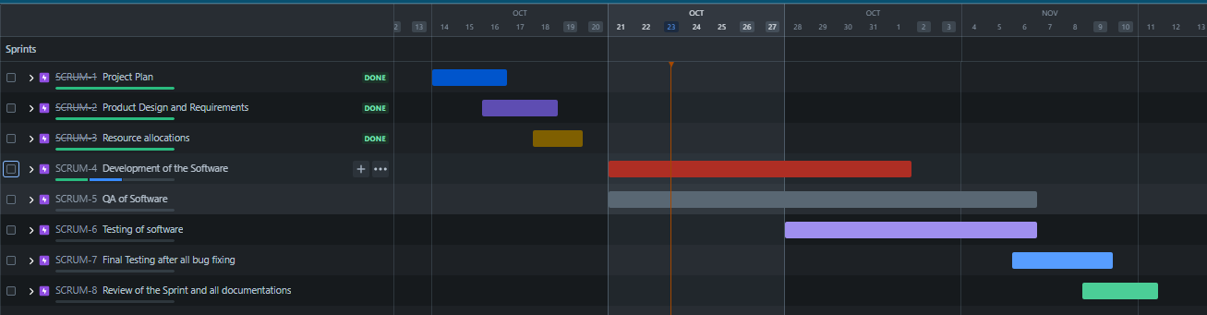

1. Stories of each and every Epic listed above

